ASSIGNMENT-2

ASSIGNMENT-1

MongoDB -Aggregation Exercises :

Import the zips.json file into your MongoDB. Database name is "population" and collection name is "zipcodes". mongoimport --db population --collection zipcodes --file zips.json.

Insert the following documents intoa movies collection :

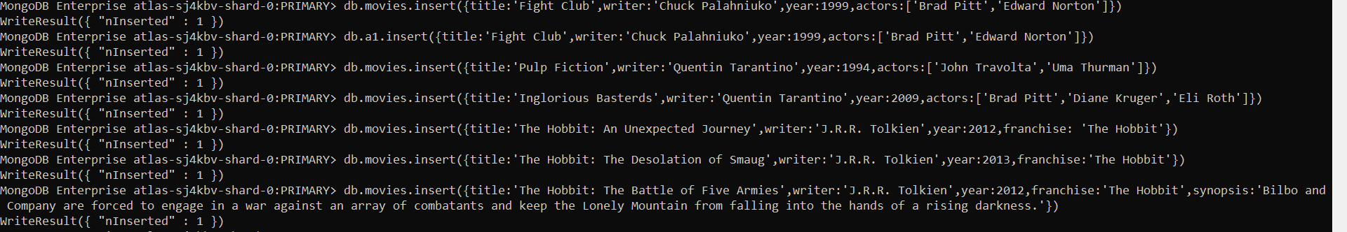

Atlanta Population:

1. get all documents

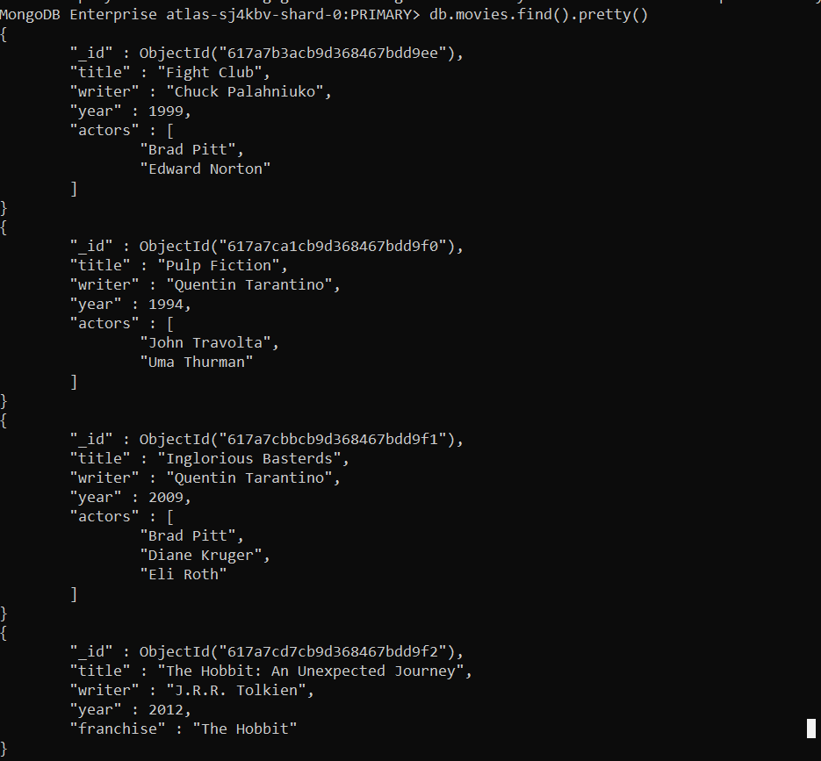

2. get all documents with writer set to "Quentin Tarantino"get all documents where actors include "Brad Pitt"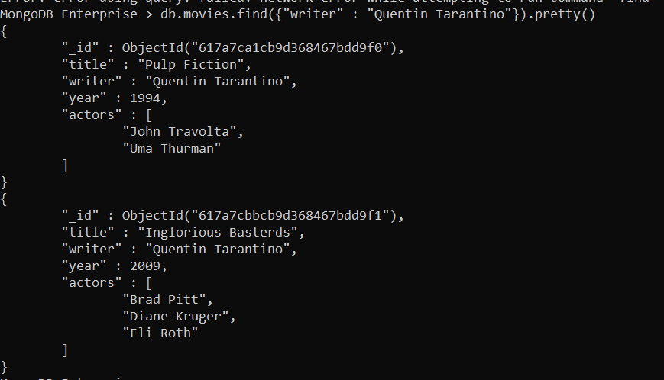

3. get all documents where actors include "Brad Pitt"



4. get all documents with franchise set to "The Hobbit"



5. get all movies released in the 90s



6.get all movies released before the year 2000 or after 2010

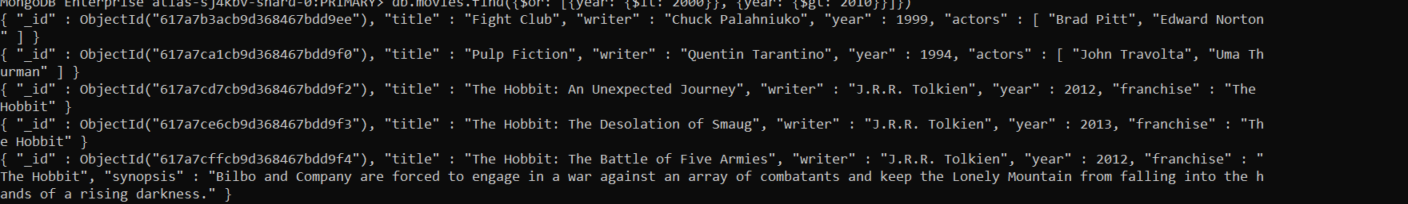

Update Documents:

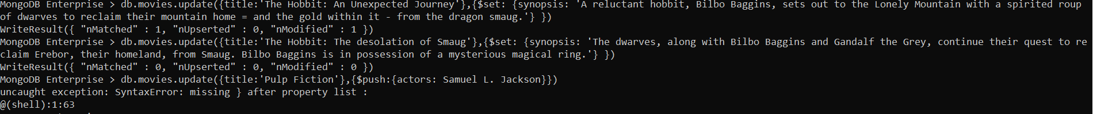

Text Search :

1.find all movies that have a synopsis that contains the word "Bilbo"

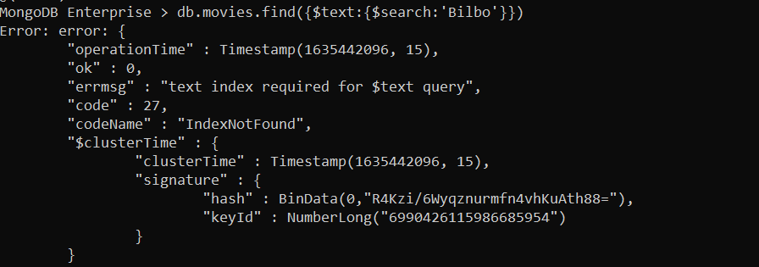

2.find all movies that have a synopsis that contains the word "Gandalf"

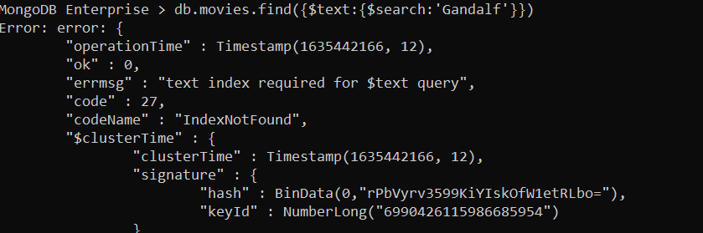

3.find all movies that have a synopsis that contains the word "Bilbo" and not the word "Gandalf"



4.find all movies that have a synopsis that contains the word "dwarves" or "hobbit"



5.find all movies that have a synopsis that contains the word "gold" and "dragon"



Delete Documents :

1.delete the movie "Pee Wee Herman's Big Adventure"



2.delete the movie "Avatar"



Insert :

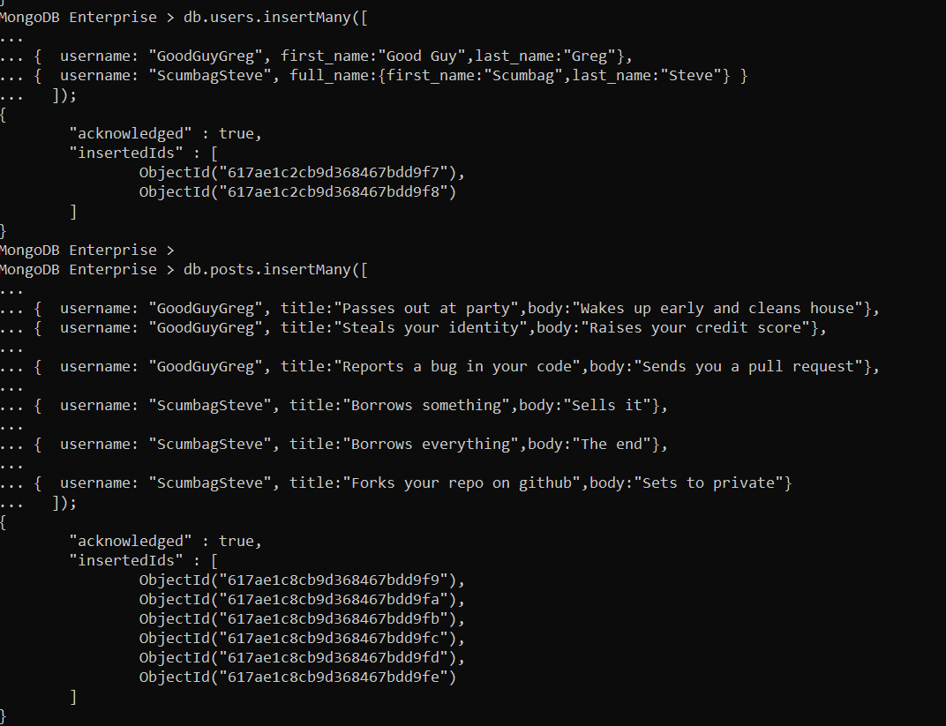

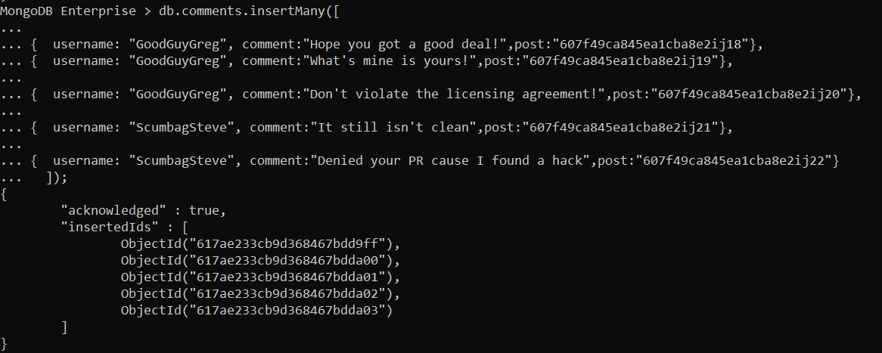

Relationships :

1.find all users

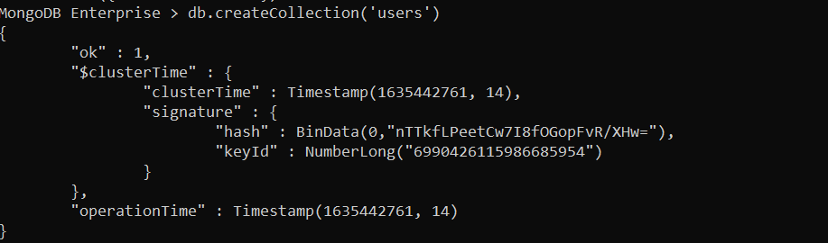

2.find all posts

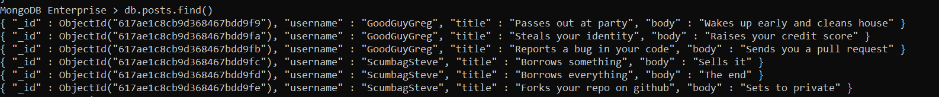

3.find all posts that was authored by "GoodGuyGreg"

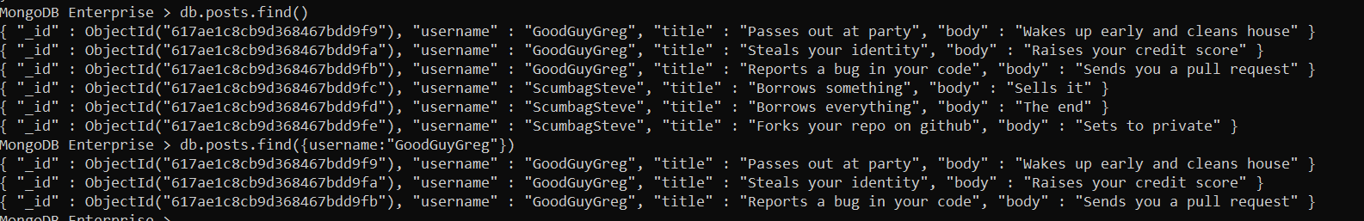

4.find all posts that was authored by "ScumbagSteve"



5.find all comments



6. find all comments that was authored by "GoodGuyGreg"



7.find all comments that was authored by "ScumbagStev”

Assignment-2 :

1.use db.zipcodes.find() to filter results to only the results where city is ATLANTA and state is GA.

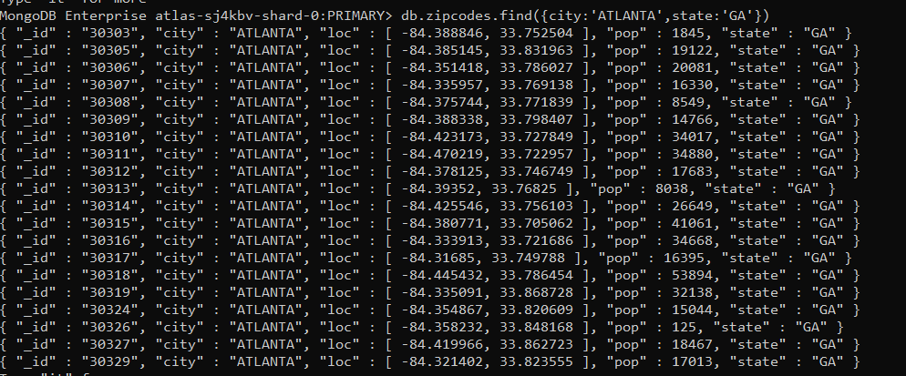

2.use db.zipcodes.aggregate with $match to do the same as above.



3. use $group to count the number of zip codes in Atlanta.



4.use $group to find the total population in Atlanta.

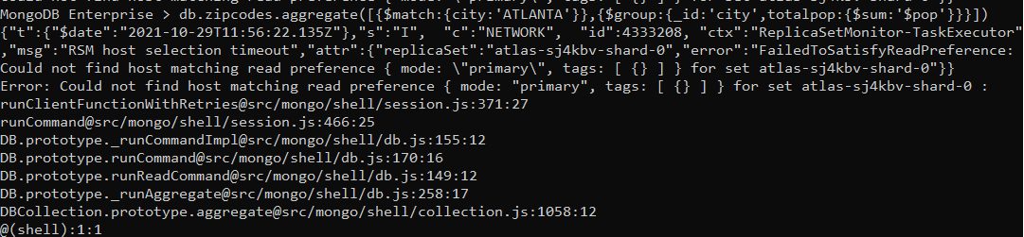

Populations By State

1.use aggregate to calculate the total population for each state

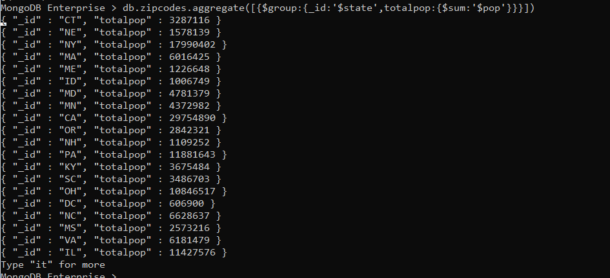

2.sort the results by population, highest first

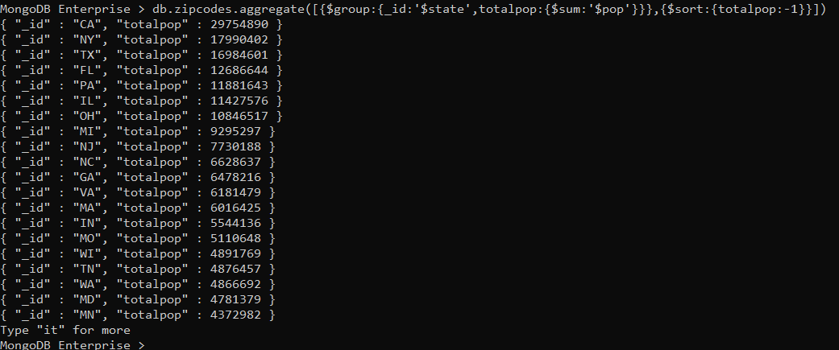

3.limit the results to just the first 3 results. What are the top 3 states in population

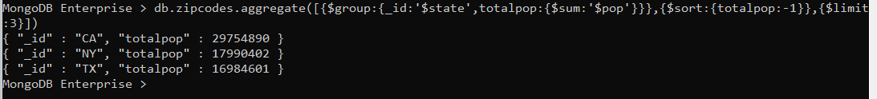

Populations by City

1.use aggregate to calculate the total population for each city (you have to use city/state combination). You can use a combination for the _id of the $group: { city: '$city', state: '$state' }

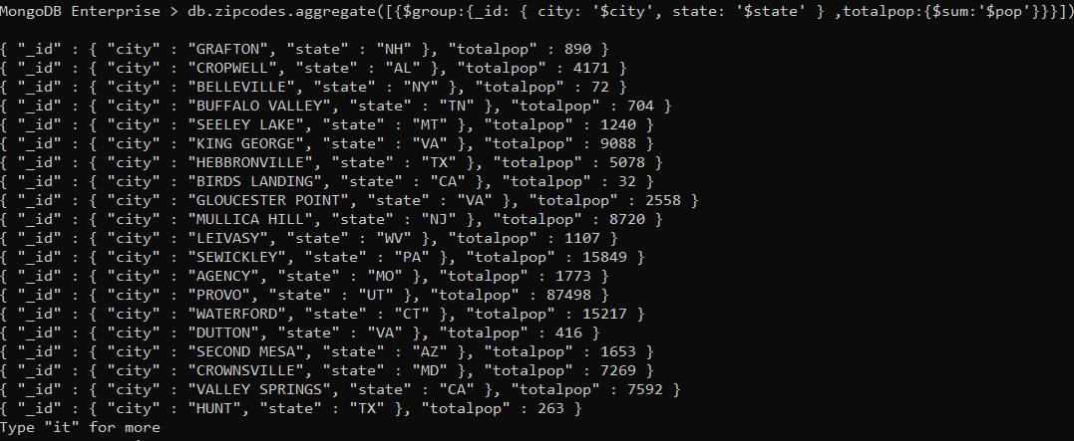

2.sort the results by population, highest first

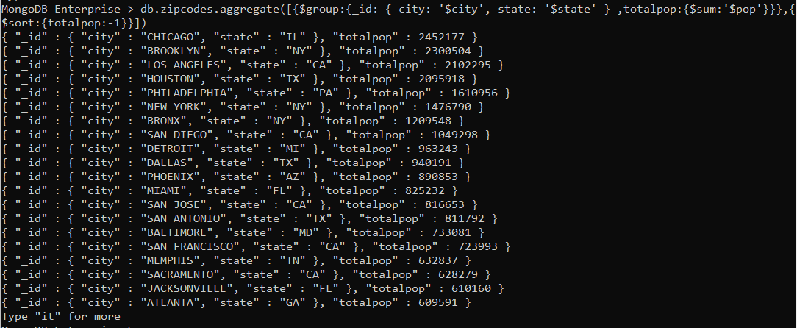

3.limit the results to just the first 3 results. What are the top 3 cities in population?



4.What are the top 3 cities in population in Texas?



Bonus :

1.Write a query to get the average city population for each state.

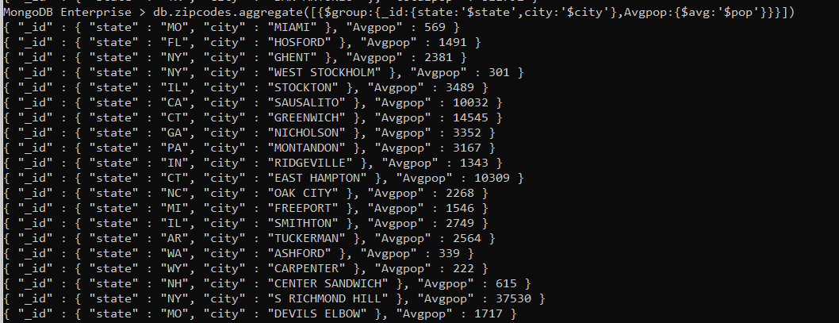

2.What are the top 3 states in terms of average city population



ASSIGNMENT-3

Mongo DB Exercises - With the Restaurants Data Set

1. Download the restaurants.zip file

2. Unzip the file, you will see restaurants.json file

3. Run the mongod server

4. Run the following command to import the json file provided. It will load the json file into the mongodb with database name - restaurants, collections name - addresses mongoimport --db restaurants --collection addresses --file restaurants.json

5. Run mongo shell command

6. show databases

7. use restaurants

8. db.addresses.find() should print entire json data 9. Then start working on the following exercises and submit your queries as the